**10.1 Warm-Up**

**1.**

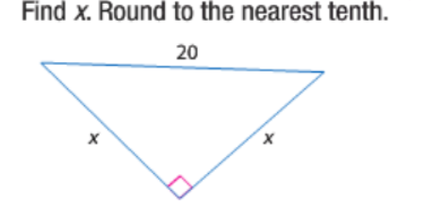

**2.**

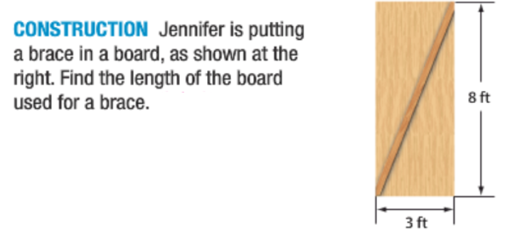

**3.**

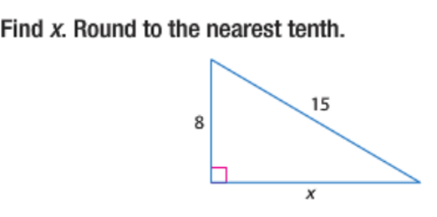

**10.1 Circles and Circumference**

**Target:________________________________________________**

**______________________________________________________**

