10-1 Skills Practice
Circles and Circumference

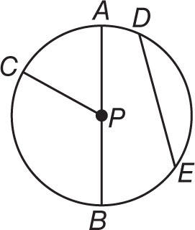
For Exercises 1-7, refer to ⨀P.

1. Name the circle. 2. Name a radius.

3. Name a chord. 4. Name a diameter.

5. Name a radius not drawn as part of a diameter.

6. Suppose the diameter of the circle is 16 centimeters. Find the radius.

7. If PC = 11 inches, find AB.

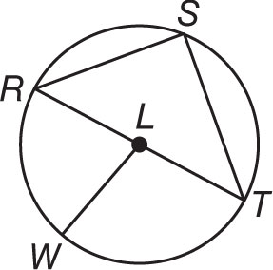
For Exercises 8–14, refer to ⨀L.

8. Name the circle. 9. Name a radius.

10. Name a chord. 11. Name a diameter.

12. Name a radius not drawn as part of a diameter.

13. Suppose the radius of the circle is 3.5 yards. Find the diameter.

14. If RT = 19 meters, find LW.

