10-3 Skills Practice
Arcs and Chords

ALGEBRA Find the value of x in each circle.

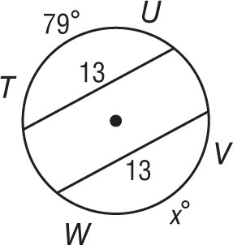
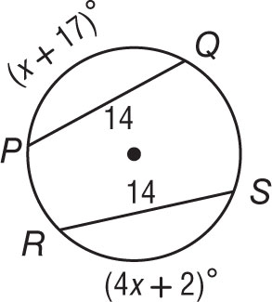
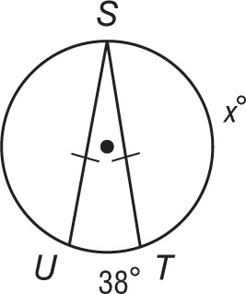
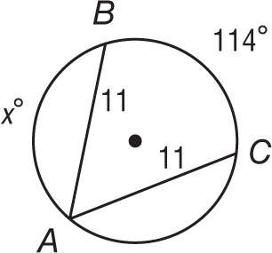
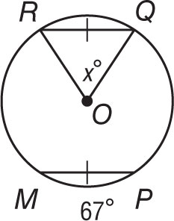
1. 2.

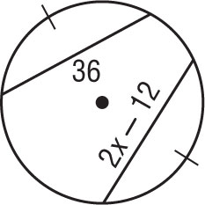
3. 4.

5. 6.

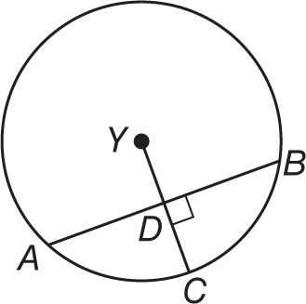
In ⨀Y the radius is 34, AB = 60, and m$\hat{AC}$ = 71. Find each measure.

7. m$\hat{BC}$ 8. m$\hat{AB}$

9. AD 10. BD

11. YD 12. DC

13. In ⨀U, VW = 20 and 14. In ⨀Z, $\hat{TR}$ ≅ $\hat{TV}$, SZ = x + 4, and
YZ = 5x. What is x? UZ = 2x − 1. What is x?
