**10-4 Practice Day 1**

***Inscribed Angles***

**Find each measure.**

**1.** *m $\hat{XY }$* **2.** *m*∠*E*

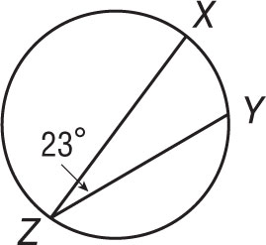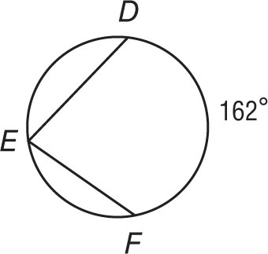

**3.** *m*∠ *R* **4.** *m $\hat{MP}$*

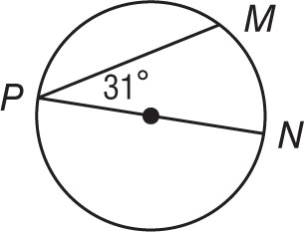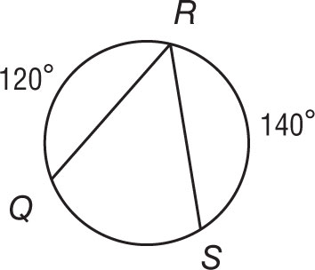

**ALGEBRA Find each measure.**

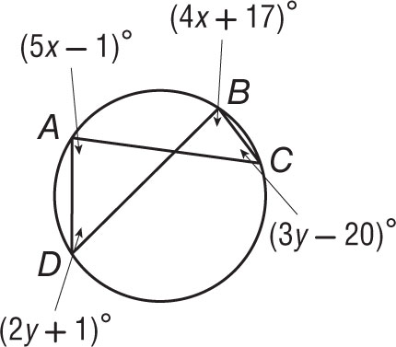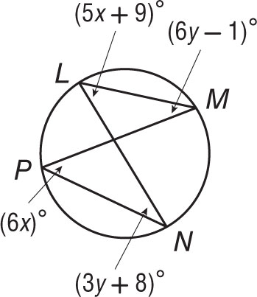

**5.** *m*∠*N* **7.** *m*∠*C*

**6.** *m*∠*L* **8.** *m*∠*A*

**Find each measure.**

**9.** *m $\hat{AB}$* **10.** *m*∠*X*

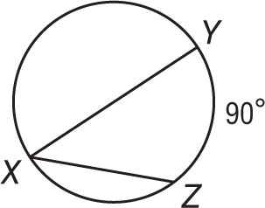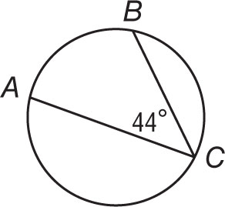

**11.** *m $\hat{JK}$* **12.** *m*∠*Q*

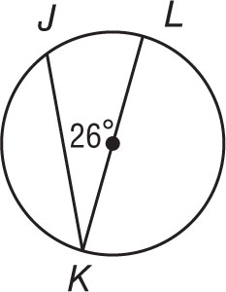

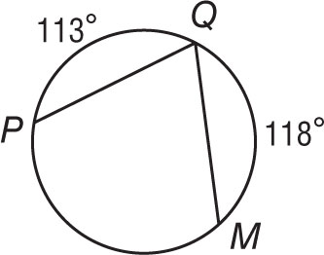

**ALGEBRA Find each measure.**

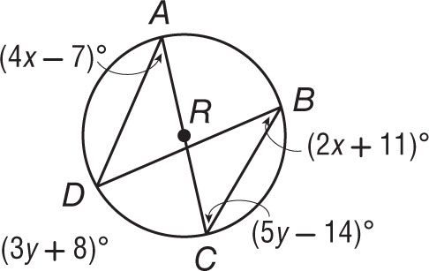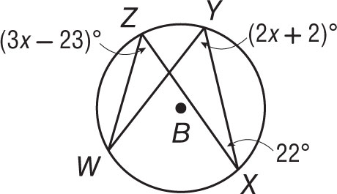 **13.** *m*∠*W* **14.** *m*∠*A*

**15.** *m*∠*Y* **16.** *m*∠*D*