**Name:_________________________________**

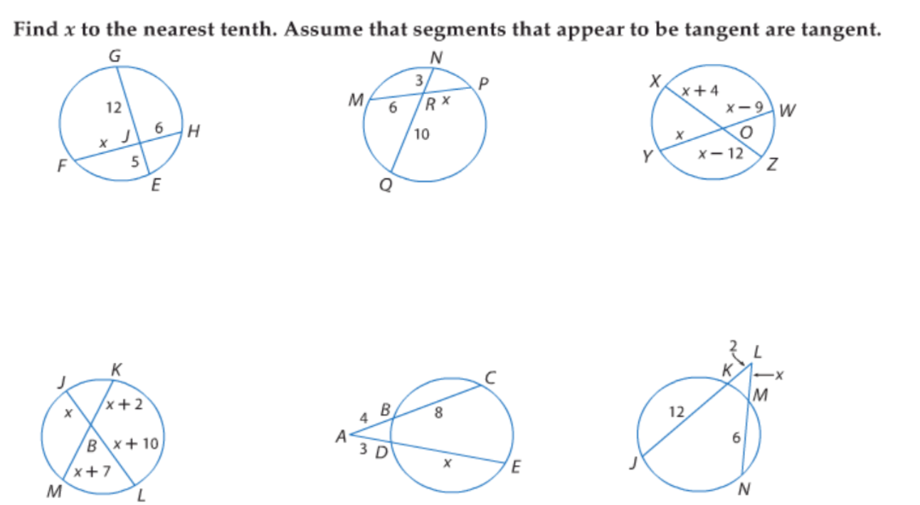**10.7 Practice Day 1**



