11-1 Skills Practice
Areas of Parallelograms and Triangles

Find the perimeter and area of each parallelogram or triangle. Round to the nearest tenth if necessary.
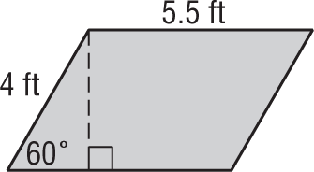
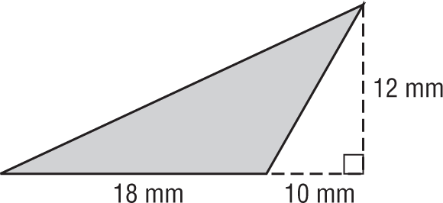
1. 2.

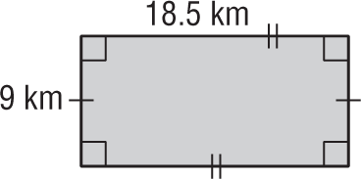
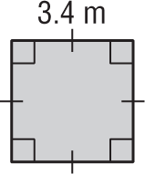
3. 4.

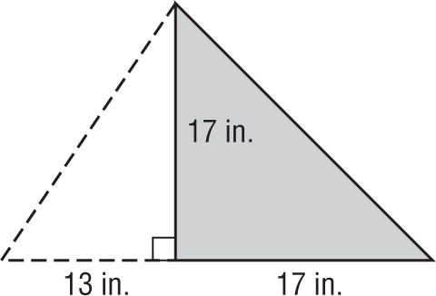
5. 6.
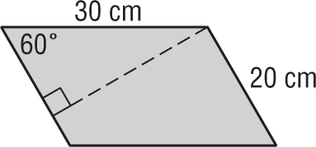

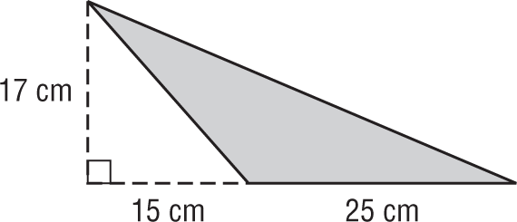
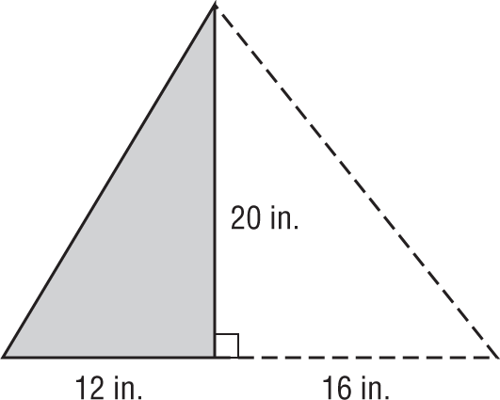
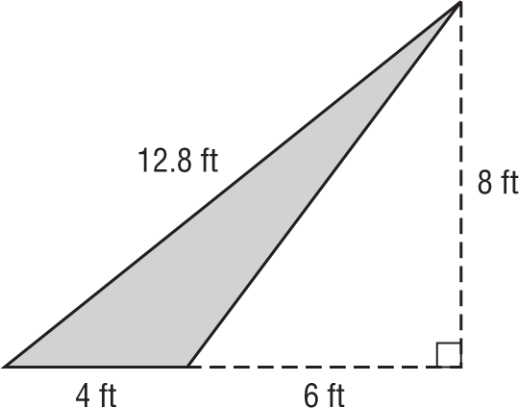
7. 8. 9.

10. The height of a parallelogram is 5 feet more than its base. If the area of the parallelogram is 204 square feet,
find its base and height.

11. The base of a triangle is four times its height. If the area of the triangle is 242 square millimeters,
find its base and height.

12. FRAMING A rectangular poster measures 42 inches by 26 inches. A frame shop fitted the poster with a
half-inch mat border.

a. Find the area of the poster.

b. Find the area of the mat border.

13. PACKAGING A box with a square opening is squashed into the rhombus shown below.

What is the area of the opening?

14. RUNNING Jason jogs once around a city block shaped like a parallelogram.

How far did Jason jog?

15. SHADOWS A rectangular billboard casts a shadow on the ground in the shape of a parallelogram. What is the area of the ground covered by the shadow? Round your answer to the nearest tenth.
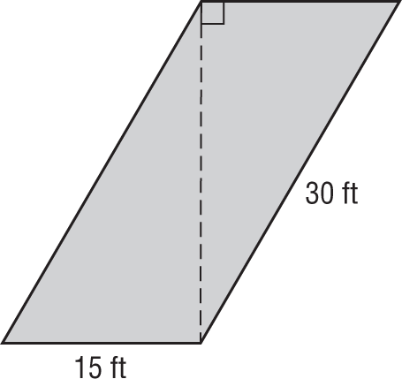

16. PATHS A concrete path shown below is made by joining several parallelograms.
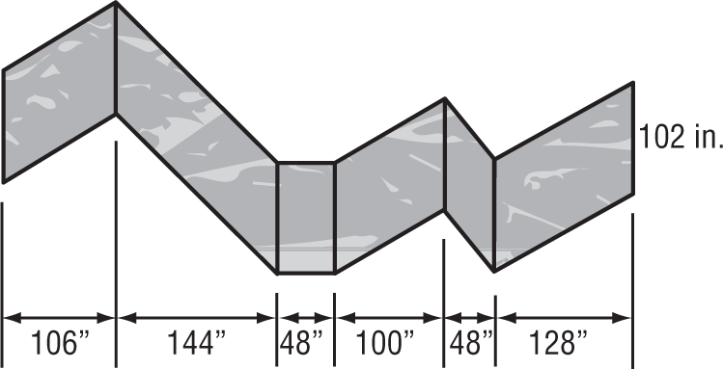

What is the total area of the path?

