11-2 Skills Practice
Areas of Trapezoids, Rhombi, and Kites

Find the area of each trapezoid, rhombus, or kite.
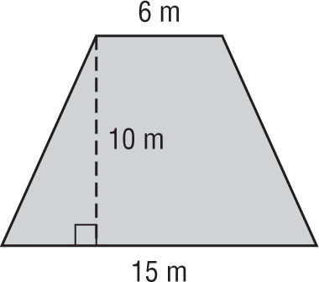
1. 2.
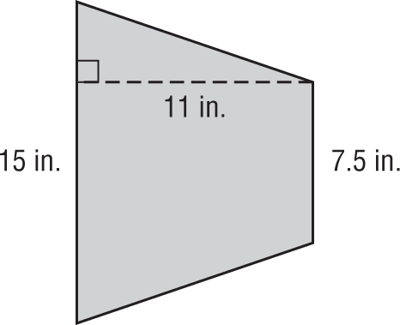

3. 4.

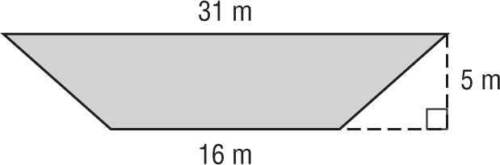
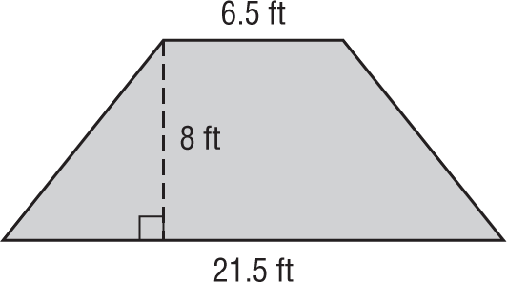

5. 6.
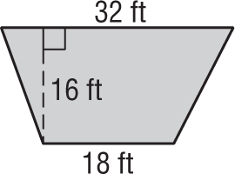
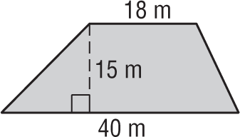

7. 8.
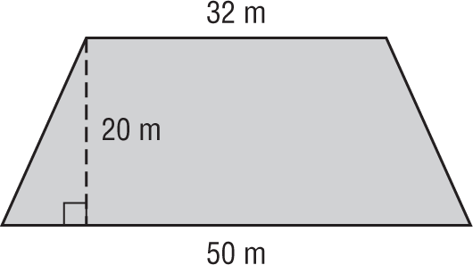
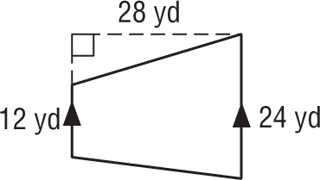

9. 10.
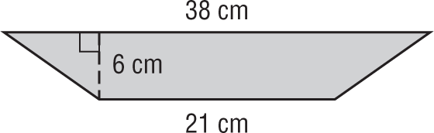
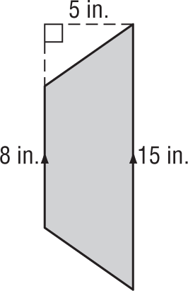

11.
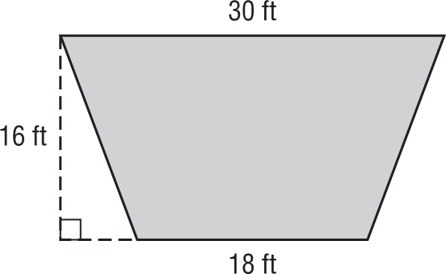

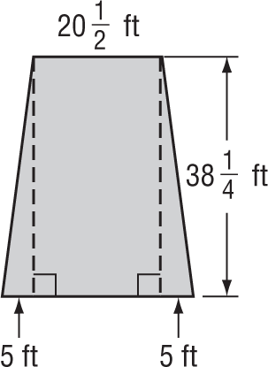
12. OPEN ENDED Ryan runs a landscaping business. A new customer has a trapezoidal shaped backyard, shown at the right. How many square feet of grass will Ryan have to mow?

