11-2 Skills Practice
Areas of Trapezoids, Rhombi, and Kites

Find the area of each trapezoid, rhombus, or kite.
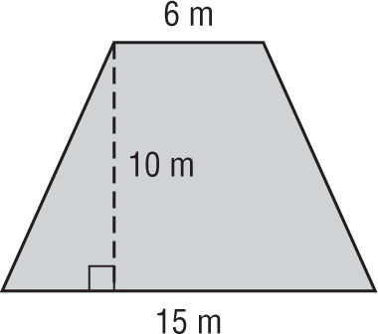
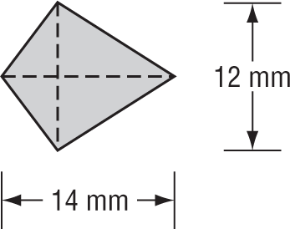
1. 2.

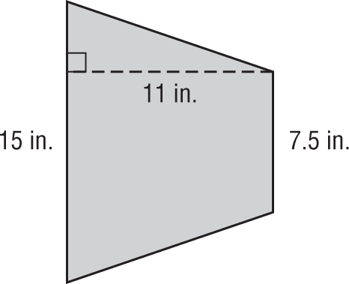
3. 4.
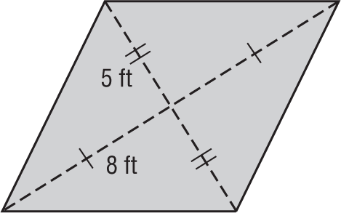

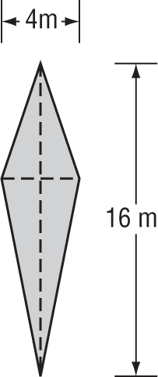
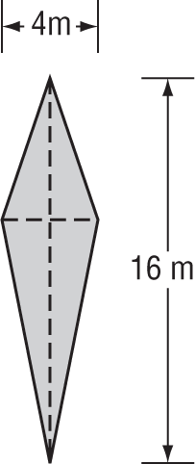
5. 6.

ALGEBRA Find each missing length.
7. A trapezoid has base lengths of 6 and 15 centimeters with an area of 136.5 square centimeters.
What is the height of the trapezoid?

8. One diagonal of a kite is four times as long as the other diagonal. If the area of the kite is 72 square meters,
what are the lengths of the diagonals?

9. A trapezoid has a height of 24 meters, a base of 4 meters, and an area of 264 square meters.
What is the length of the other base?

Find the area of each trapezoid, rhombus, or kite.
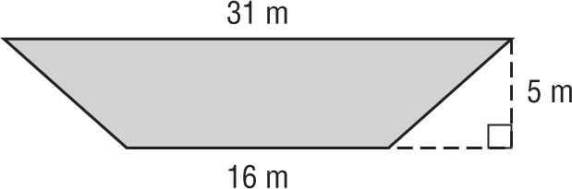
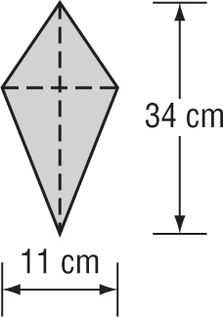
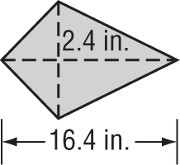
10. 11. 12.

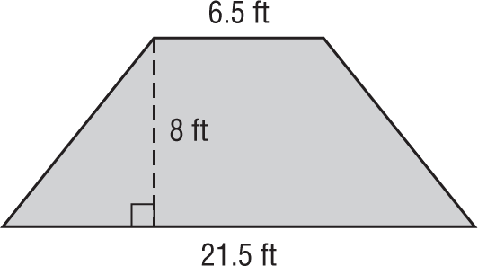
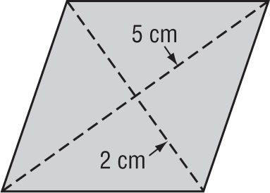
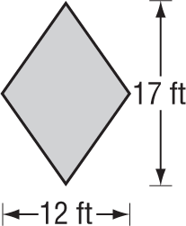
13. 14. 15.

ALGEBRA Find each missing length.
16. A trapezoid has base lengths of 19.5 and 24.5 centimeters with an area of 154 cm².
What is the height of the trapezoid?

17. One diagonal of a kite is twice as long as the other diagonal. If the area of the kite is 400 square meters,
what are the lengths of the diagonals?

18. A trapezoid has a height of 40 inches, a base of 15 inches, and an area of 2400 square inches.
What is the length of the other base?

19. DESIGN Mr. Hagarty used 16 congruent rhombi-shaped tiles to design the midsection of the backsplash area above a kitchen sink. The length of the design is 27 inches and the total area is 108 square inches.

a. Find the area of one rhombus.

b. Find the length of each diagonal.

