11-3 Practice
Areas of Circles and Sectors

Find the area of each circle. Round to the nearest tenth.
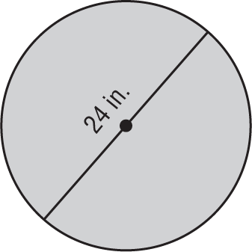
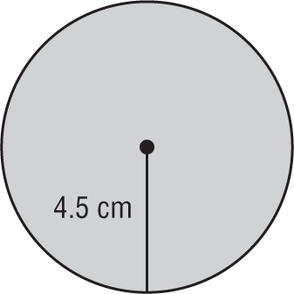
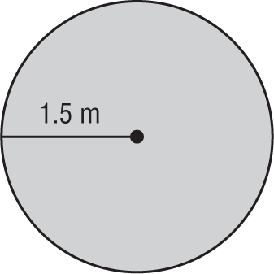
1. 2. 3.

Find the indicated measure. Round to the nearest tenth.
4. The area of a circle is 3.14 square centimeters. Find the diameter.

5. Find the diameter of a circle with an area of 855.3 square millimeters.

6. The area of a circle is 201.1 square inches. Find the radius.

7. Find the radius of a circle with an area of 2290.2 square feet.

Find the area of each shaded sector. Round to the nearest tenth.
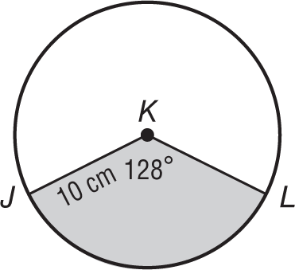
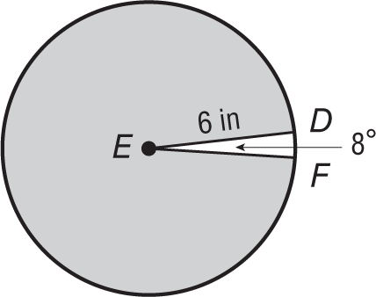
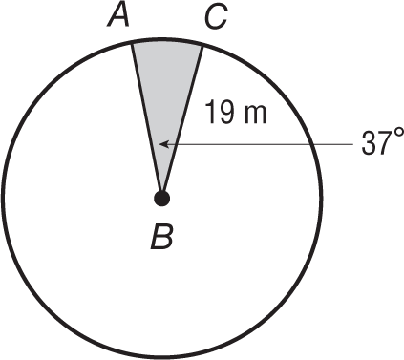
8. 9. 10.

11. CLOCK Sadie wants to draw a clock face on a circular piece of cardboard. If the clock face has a diameter of 20 centimeters and is divided into congruent pieces so that each sector is 30°, what is the area of each piece?

Find the area of each circle.
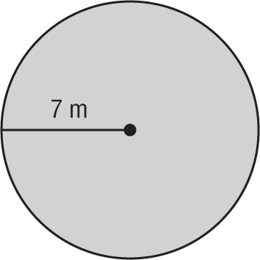
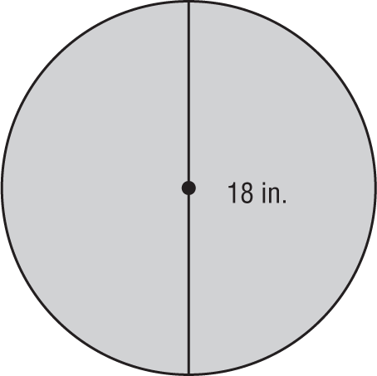
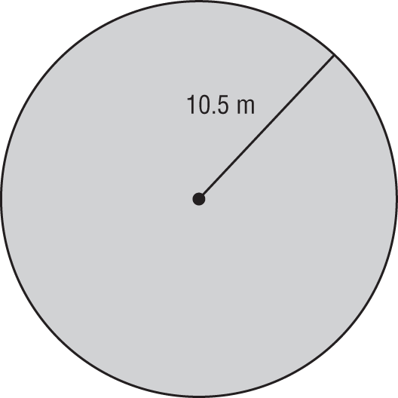
12. 13. 14.

Find the indicated measure. Round to the nearest tenth.
15. The area of a circle is 132.7 square centimeters. Find the diameter.

16. Find the diameter of a circle with an area of 1134.1 square millimeters.

17. The area of a circle is 706.9 square inches. Find the radius.

18. Find the radius of a circle with an area of 2827.4 square feet.

Find the area of each shaded sector. Round to the nearest tenth.
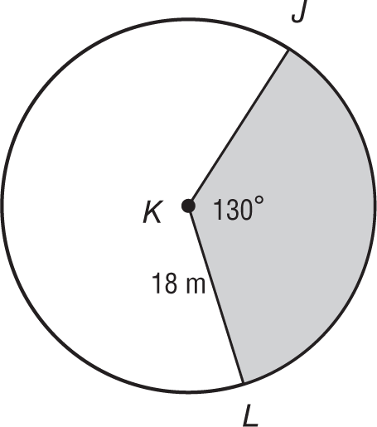
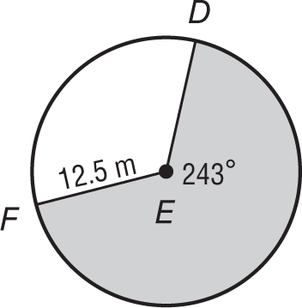
19. 20. 21.
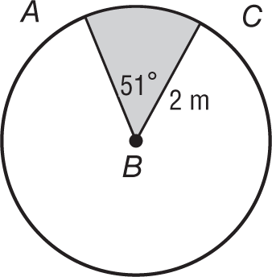

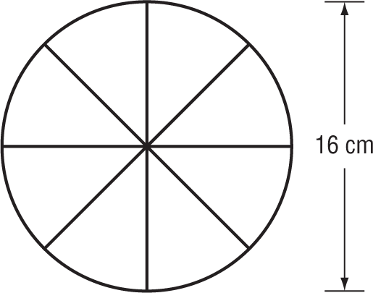
22. GAMES Jason wants to make a spinner for a new board game he invented. The spinner is a circle divided into 8 congruent pieces, what is the area of each piece to the nearest tenth?

