11-5 Practice
Areas of Similar Figures

For each pair of similar figures, find the area of the shaded figure.
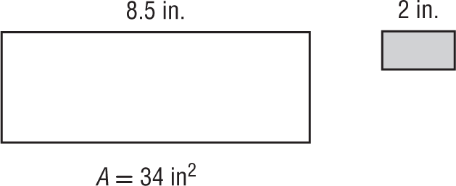
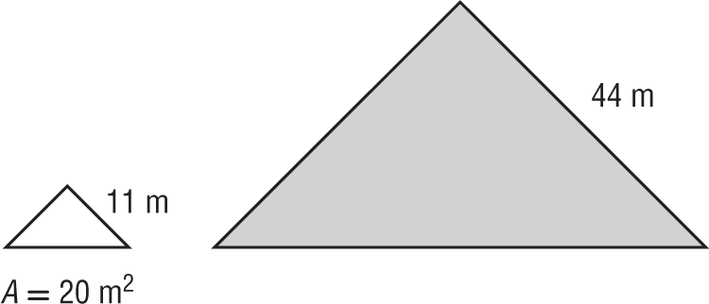
1. 2.

For each pair of similar figures, use the given areas to find the scale factor from the unshaded to the shaded figure. Then find x.
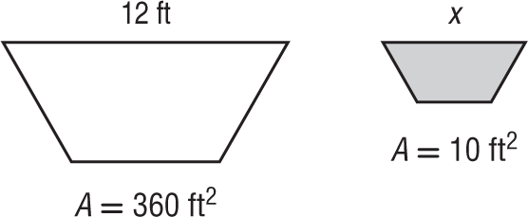
3. 4.
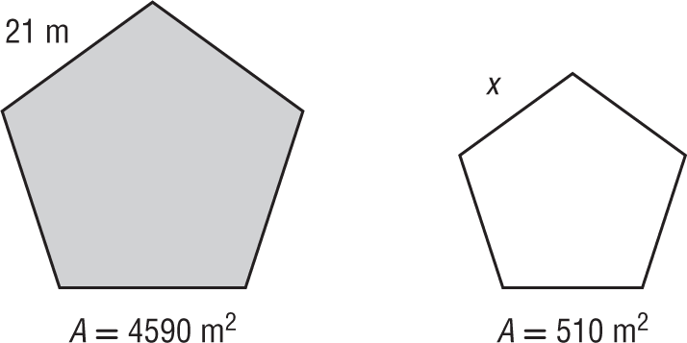

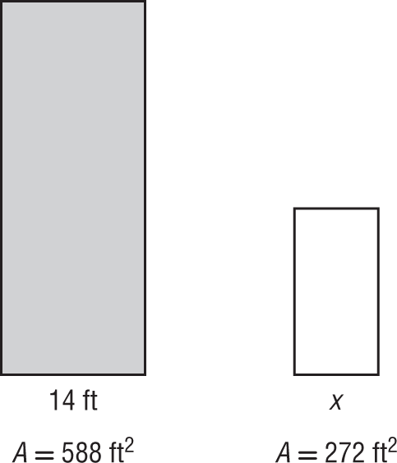
5. 6.
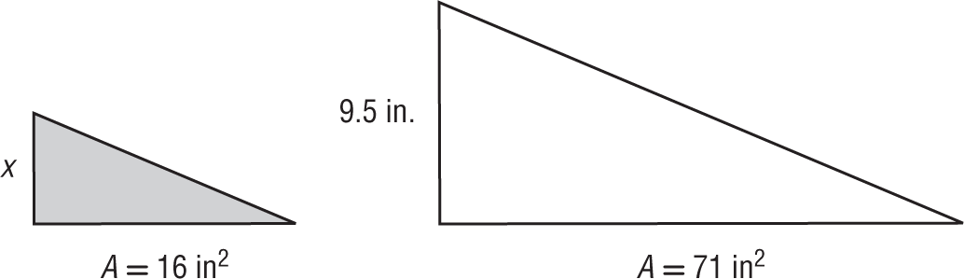

7. SCIENCE PROJECT Matt has two posters for his science project. Each poster is a rectangle. The length of the larger poster is 11 inches. The length of the smaller poster is 6 inches. What is the area of the smaller poster if the larger poster is 93.5 square inches?

For each pair of similar figures, find the area of the shaded figure.
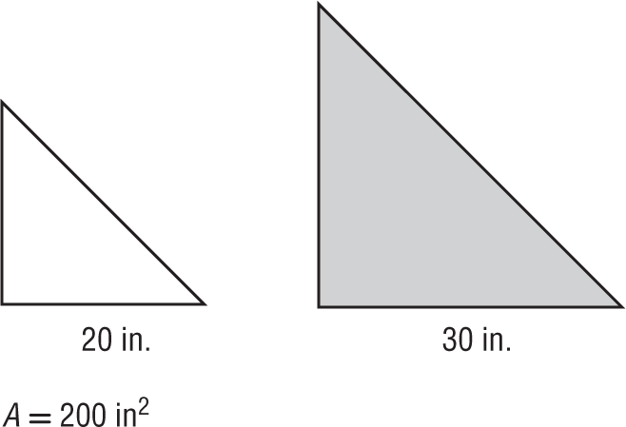
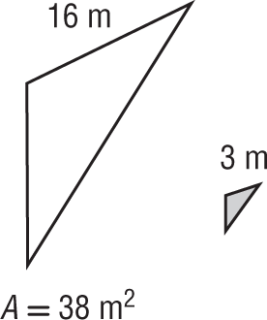
8. 9.

For each pair of similar figures, use the given areas to find the scale factor from the unshaded to the shaded figure. Then find x.
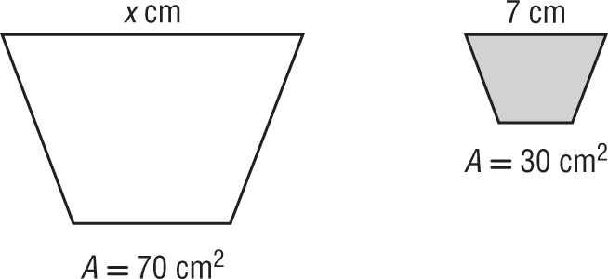
10. 11.
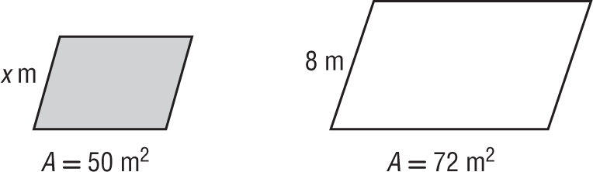

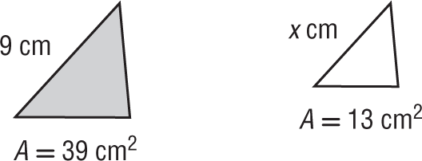
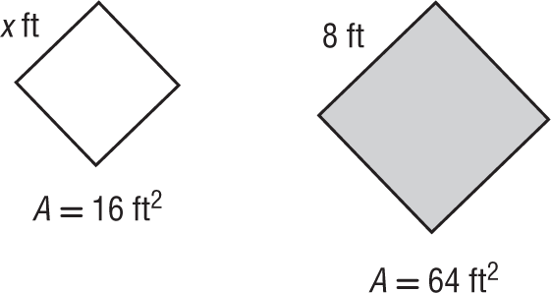
12. 13.

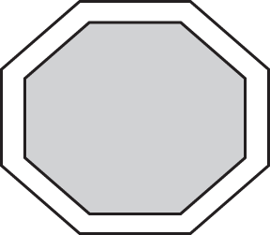
14. ARCHERY A target consists of two concentric similar octagons. The outside octagon has a side length of 2 feet and an area of 19.28 square feet. If the inside octagon has a side length of 1.5 feet, what is the area of the inside octagon?

For each pair of similar figures, find the area of the shaded figure. Round to the nearest tenth if necessary.
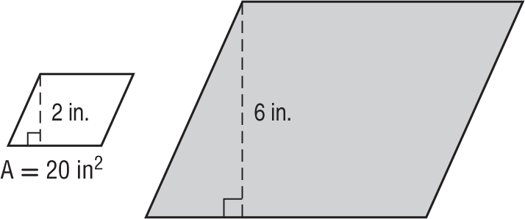
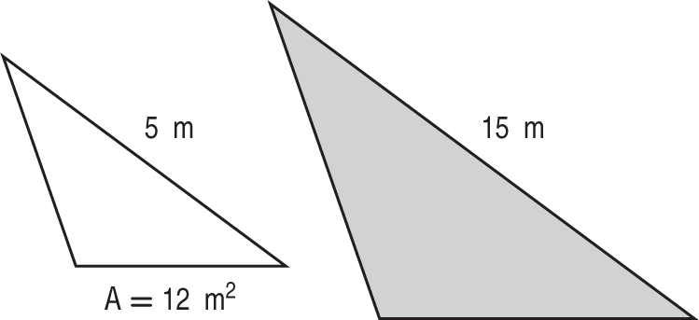
15. 16.

17. 18.
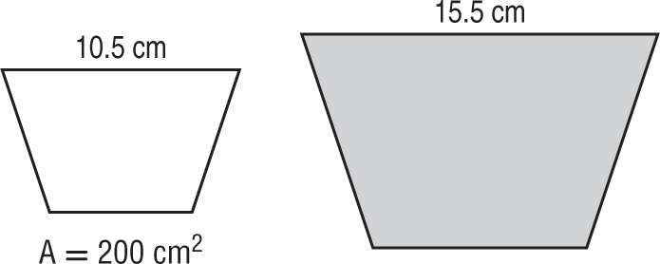
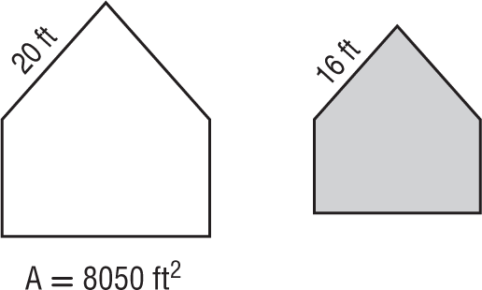

For each pair of similar figures, use the given areas to find the scale factor from the unshaded to the shaded figure. Then find x.
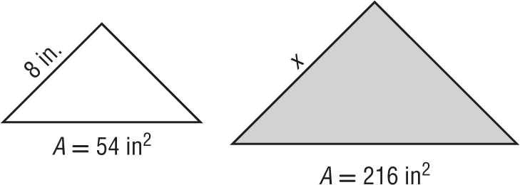
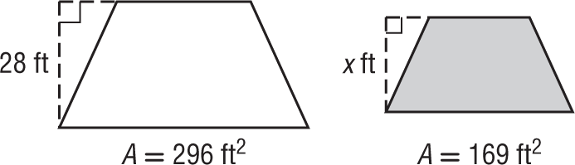
19. 20.

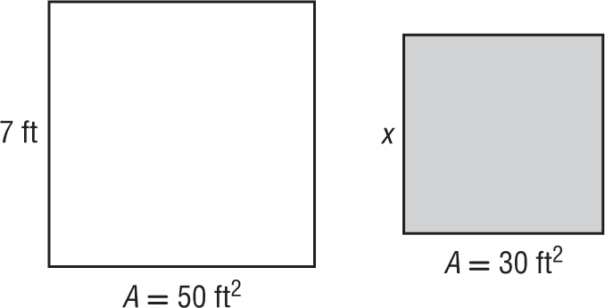
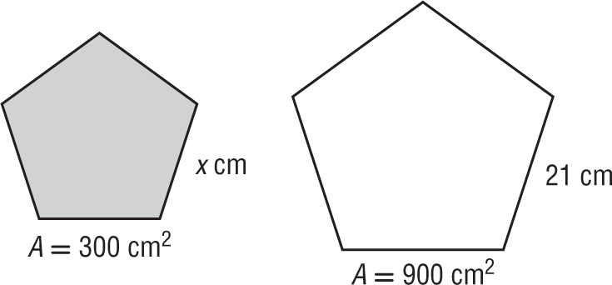
21. 22.

23. CHANGING DIMENSIONS A polygon has an area of 225 square meters. If the area is tripled, how does each side length change?
24. CAKE Smith’s Bakery is baking several large cakes for a community festival. The cakes consist of two geometrically similar shapes as shown. If 50 pieces of cake can be cut from the smaller cake, how many pieces of the same size can be cut from the larger cake? Round to the nearest piece of cake.

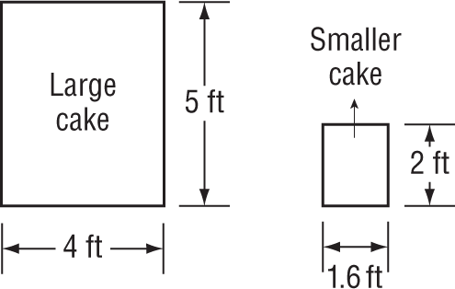

25. PINS Carla has a shirt with decorative pins in the shape of equilateral triangles. The pins come in two sizes. The larger pin has a side length that is three times longer than the smaller pin. If the area of the smaller pin is 6.9 square centimeters, what is the approximate area of the larger pin?

26. FOUNTAIN A local park has two fountains in the shape of similar trapezoids as shown. A cement company charges $1000 to pour the cement needed to go under the smaller fountain. How much should the town budget for the cement for both fountains? Explain.

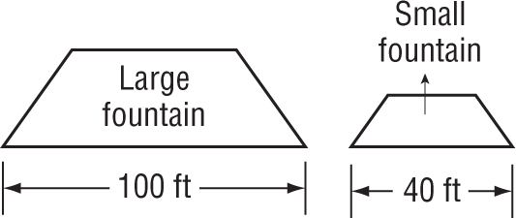

27. SCULPTURE An artist creates metal sculptures in the shape of regular octagons. The side length of the larger sculpture is 7 inches, and the area of the base of the smaller sculpture is 19.28 square inches.

a. What is the side length of the smaller sculpture?

b. The artist is going to pack the sculptures in a circular box to take them to an art show. Will the larger sculpture fit in a circular box with a 15-inch diameter? Explain your reasoning.

