13-3 Skills Practice
Geometric Probability

Point X is chosen at random on $\overline{LP}$. Find the probability of each event.

1. P(X is on $\overline{LN}$)

2. P(X is on $\overline{MO}$)

Find the probability that a point chosen at random lies in the shaded region.

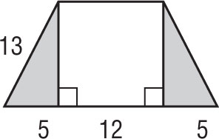
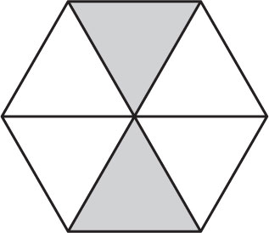
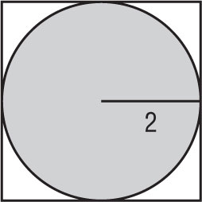
3. 4. 5.

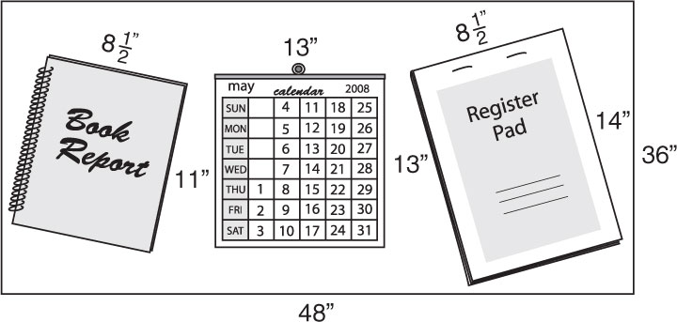
6. DESKWORK The diagram shows the top of a student’s desk at home. A dart is dropped on the desk. What is the probability the dart lands on the book report?

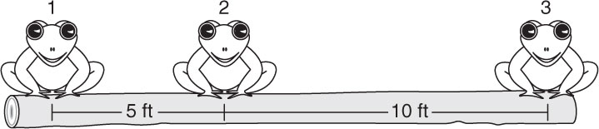
7. FROGS Three frogs are sitting on a 15-foot log. The first two are spaced 5 feet apart and the third frog is 10 feet away from the second one. What is the probability that when a fourth frog hops onto the log it lands between the first two?

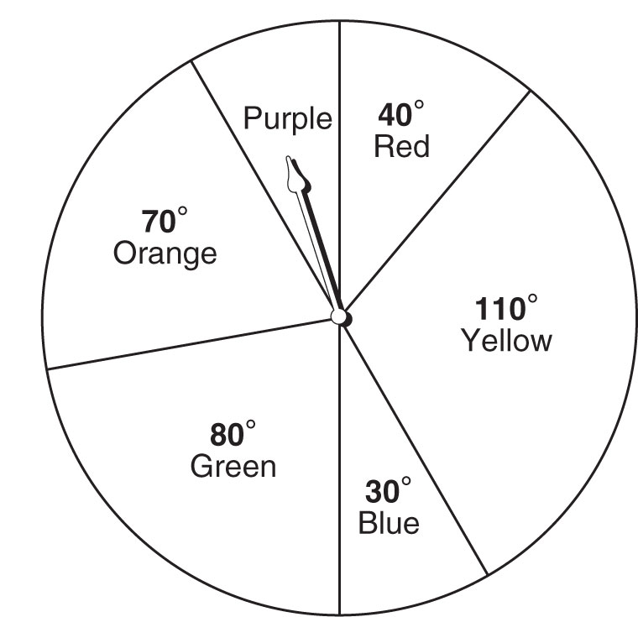
8. RADIO CONTEST A radio station is running a contest in which listeners call in when they hear a certain song.
The song is 2 minutes 40 seconds long. The radio station promised to play it
sometime between noon and 4 P.M. If you tune in to that radio station
during that time period, what is the probability the song is playing?

Use the spinner to find each probability. If the spinner lands
on a line it is spun again.

9. P(pointer landing on yellow)

10. P(pointer landing on orange)

