8-1 Practice
Geometric Mean

Find the geometric mean between each pair of numbers.
1. 2 and 8 2. 9 and 36 3. 4 and 7

4. 5 and 10 5. 28 and 14 6. 7 and 36

Find x, y and z.

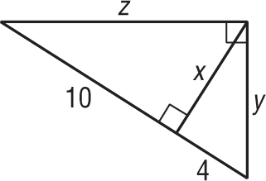
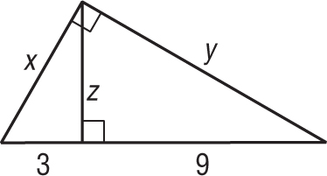
7. 8.

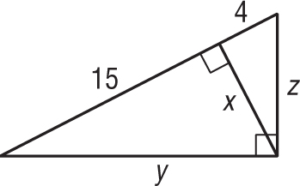
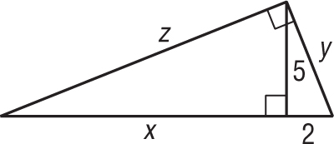
9. 10.

