8-2 Practice
The Pythagorean Theorem and Its Converse

Find x.
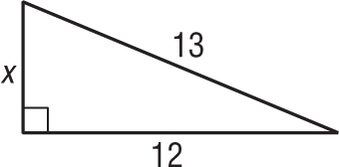
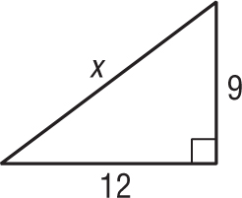
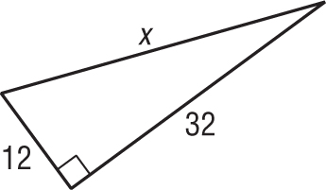
1. 2. 3.

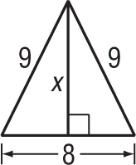
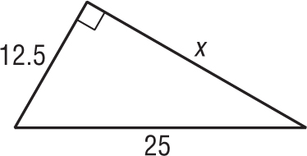
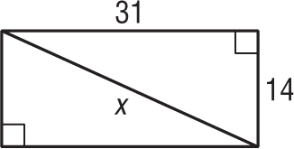
4. 5. 6.

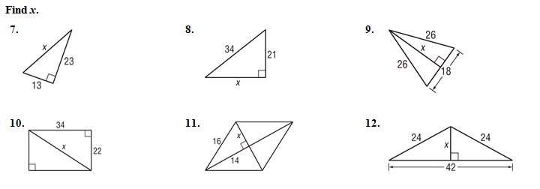

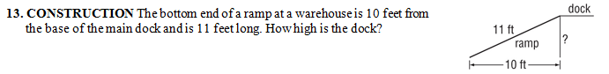

14. SIDEWALKS Construction workers are building a marble sidewalk around a park that is shaped like a right triangle. Each marble slab adds 2 feet to the length of the sidewalk. The workers find that exactly 1071 and 1840 slabs are required to make the sidewalks along the short sides of the park. How many slabs are required to make the sidewalk that runs along the long side of the park?

15. TETHERS To help support a flag pole, a 50-foot-long tether is tied to the pole at a point 40 feet above the ground. The tether is pulled taut and tied to an anchor in the ground. How far away from the base of the pole is the anchor?

16. FLIGHT An airplane lands at an airport 60 miles east and 25 miles north of where it took off.

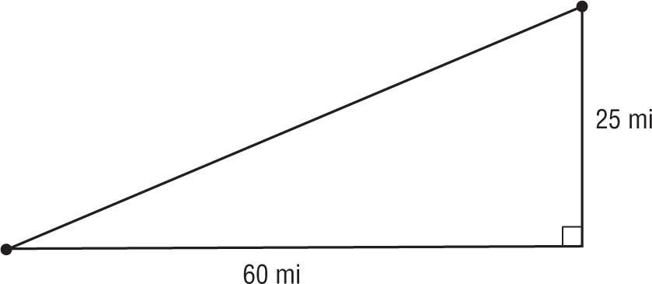

How far apart are the two airports?

