**Find the sine, the cosine, and the tangent of the acute angles of the triangle.**

**Express each answer as a decimal rounded to four places.**

**1.**

**Find the value of each variable.**

**Round decimals to the nearest tenth.**



**3.** **4.**

**5.** **6.**



**7.** **8.**

**9. A train is traveling up a slight grade with an angle of inclination of only $2°$. After traveling 1 mile what is the vertical change in feet?**



**Find the value of each variable.**

**Round decimals to the nearest tenth.**



**10.** **11.**



**12.**

**13. You are measuring the height of a flag pole. You stand 19 feet from the base of the pole. You measure the angle of elevation from a point on the ground to the top of the pole to be $64°$.**

**Estimate the height of the pole.**

**14. RAMPS** Louie makes a 60-foot ramp that rises from the first floor to the second floor of a parking garage. The ramp makes a 15° angle with the ground. How high above the first floor is the second floor?

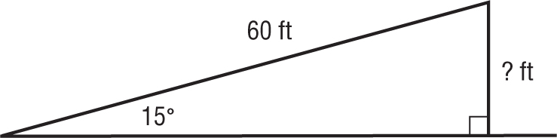

**15.**

