Name:_______________________________
8.4 Practice Day 2

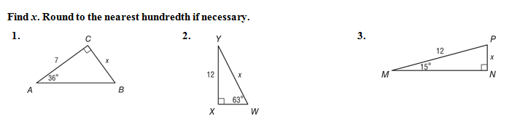

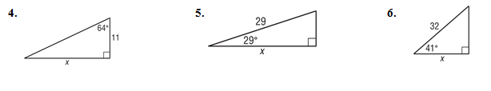

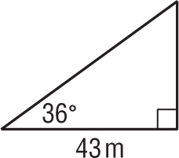
7. GEOGRAPHY Trey used a theodolite to map a region of land for his class in geomorphology. To determine the elevation of a vertical rock formation, he measured the distance from the base of the formation to his position and the angle between the ground and the line of sight to the top of the formation. The distance was 43 meters and the angle was 36°. What is the height of the formation to the nearest meter?

8. RADIO TOWERS Brittany is standing near a 200-foot-high radio tower.
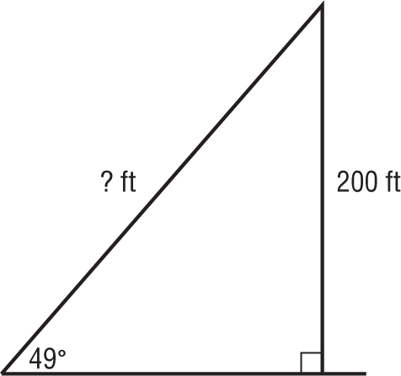

Use the information in the figure to determine how far Brittany is from the top of the tower.

9. RAMPS Louie makes a 60-foot ramp that rises from the first floor to the second floor of a parking garage. The ramp makes a 15° angle with the ground.

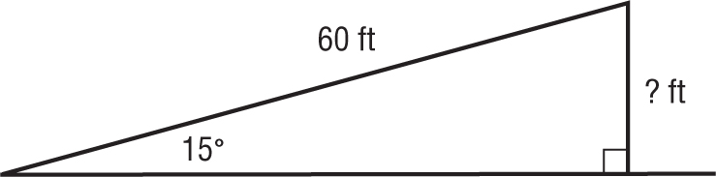

How high above the first floor is the second floor?

10. Sports Ervin is open in the corner of the end zone. If the ball is thrown from the ground at a $25°$degree angle and Ervin is 22 feet away from the throw. How far does Ervin have to jump in the air to catch the ball?

22 feet
$$25°$$

