8-5 Skills Practice
Angles of Elevation and Depression

Name the angle of depression or angle of elevation in each figure.
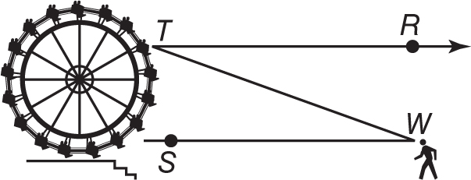
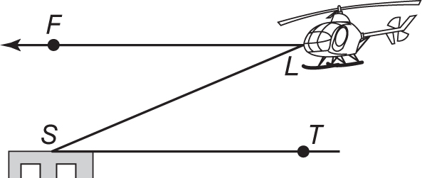
1. 2.

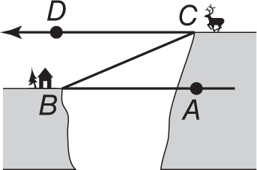
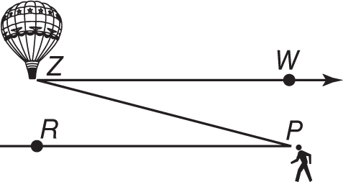
3. 4.

5. 6.
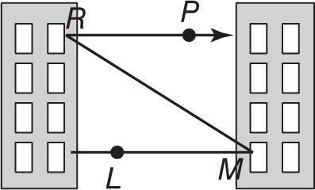
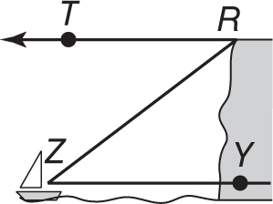

5. MOUNTAIN BIKING On a mountain bike trip along the Gemini Bridges Trail in Moab, Utah, Nabuko stopped on the canyon floor to get a good view of the twin sandstone bridges. Nabuko is standing about 60 meters from the base of the canyon cliff, and the natural arch bridges are about 100 meters up the canyon wall. If her line of sight is 5 meters above the ground, what is the angle of elevation to the top of the bridges? Round to the nearest tenth degree.

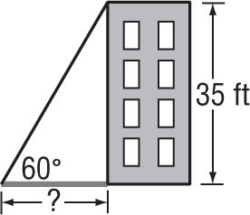
6. SHADOWS Suppose the sun casts a shadow off a 35-foot building. If the angle of elevation to the sun is 60°, how long is the shadow to the nearest tenth of a foot?

7. WATER TOWERS A student can see a water tower from the closest point of the soccer field at San Lobos High School. The edge of the soccer field is about 110 feet from the water tower and the water tower stands at a height of 32.5 feet. What is the angle of elevation if the eye level of the student viewing the tower from the edge of the soccer field is 6 feet above the ground? Round to the nearest tenth.

8. CONSTRUCTION A roofer props a ladder against a wall so that the top of the ladder reaches a 30-foot roof that needs repair. If the angle of elevation from the bottom of the ladder to the roof is 55°, how far is the ladder from the base of the wall? Round your answer to the nearest foot.

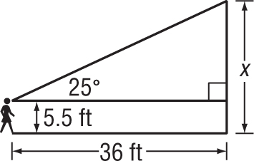
9. TOWN ORDINANCES The town of Belmont restricts the height of flagpoles to 25 feet on any property. Lindsay wants to determine whether her school is in compliance with the regulation. Her eye level is 5.5 feet from the ground and she stands 36 feet from the flagpole. If the angle of elevation is about 25°, what is the height of the flagpole to the nearest tenth?

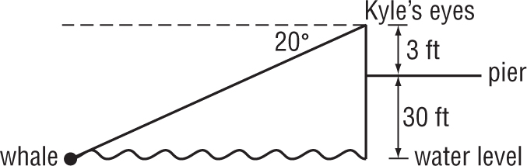
10. INDIRECT MEASUREMENT Kyle is at the end of a pier 30 feet above the ocean. His eye level is 3 feet above the pier. He is using binoculars to watch a whale surface. If the angle of depression of the whale is 20°, how far is the whale from Kyle’s binoculars? Round to the nearest tenth foot

