Name:_________________________
8.5 Practice Day 2

1. LIGHTHOUSES Sailors on a ship at sea spot the light from a lighthouse. The angle of elevation to the light is 25°.
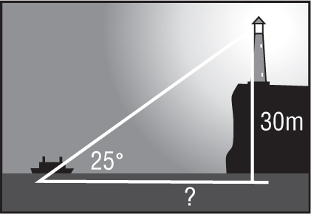

The light of the lighthouse is 30 meters above sea level. How far from the shore is the ship? Round your answer to the nearest meter.

2. . RESCUE A hiker dropped his backpack over one side of a canyon onto a ledge below. Because of the shape of the cliff, he could not see exactly where it landed.

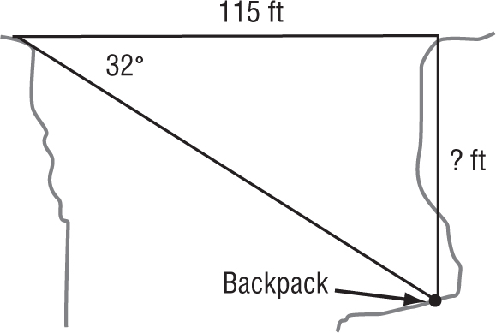

From the other side, the park ranger reports that the angle of depression to the backpack is 32°. If the width of the canyon is 115 feet, how far down did the backpack fall? Round your answer to the nearest foot.

3. AIRPLANES The angle of elevation to an airplane viewed from the control tower at an airport is 7°. The tower is 200 feet high and the pilot reports that the altitude is 5200 feet. How far away from the control tower is the airplane? Round your answer to the nearest foot.

4. 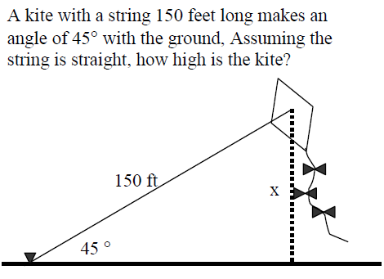

5. 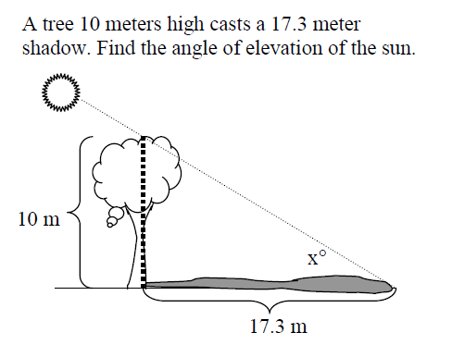

6. 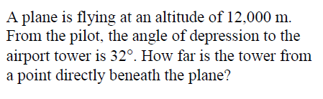

7. 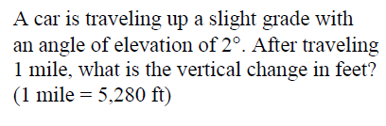

8. 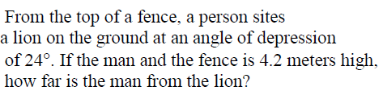

9. 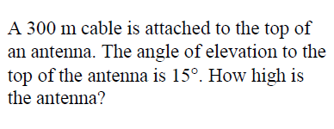

10. 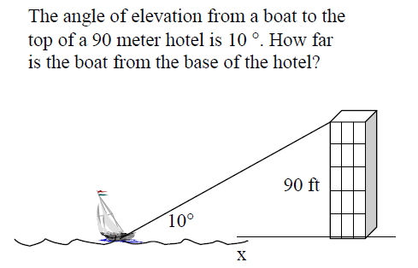

11. 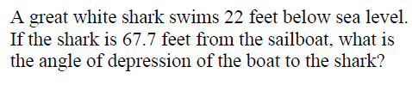

12. 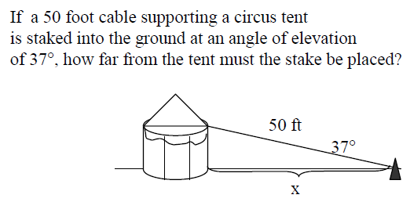

13. 