9-1 Skills Practice
Reflections

Use the given figure and line of reflection.
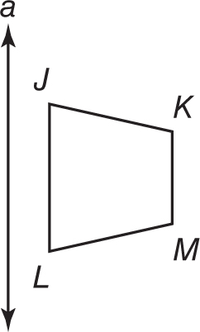
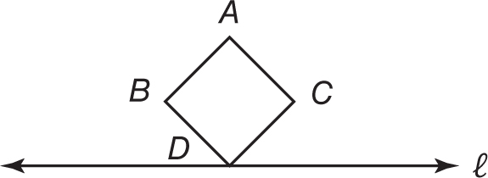
1. 2.

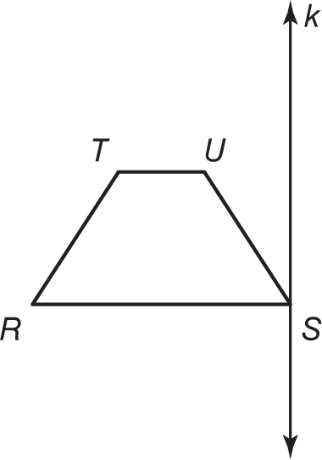
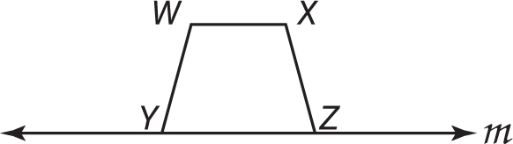
3. 4.

COORDINATE GEOMETRY Graph each figure and its image under the given reflection.
5. △ABC with vertices A(–3, 2), B(0, 1), 6. trapezoid DEFG with vertices D(0,–3),
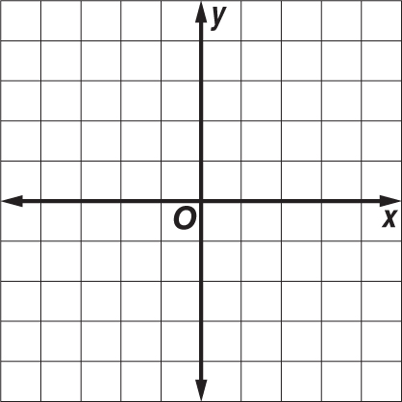
and C(–2,–3) in the line x-axis E(1, 3), F(3, 3), and G(4,–3) in the y-axis

7. parallelogram RSTU with vertices 8. square KLMN with vertices K(–1, 0),
R(–2, 3), S(2, 4), T(2,–3) and L(–2, 3), M(1, 4), and N(2, 1) in
U(–2,–4) in the line y-axis the x-axis

