9-2 Practice
Translations

Graph each figure and its image along the given vector.
1. △JKL with vertices J(–4, –4), 2. quadrilateral LMNP with vertices L(4, 2),
K(–2, –1), and L(2, –4); $〈2, 5 〉$ M(4, –1), N(0, –1), and P(1, 4); $〈-4, -3〉$
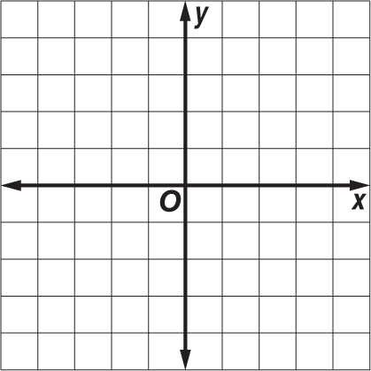
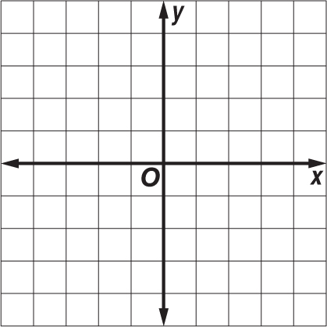

3. quadrilateral TUWX with vertices 4. pentagon DEFGH with vertices D(–1, –2),
T(–1, 1), U(4, 2), W(1, 5), and X(–1, 3); E(2, –1), F(5, –2), G(4, –4), and H(1, –4);
〈–2, –4〉 〈–1, 5〉
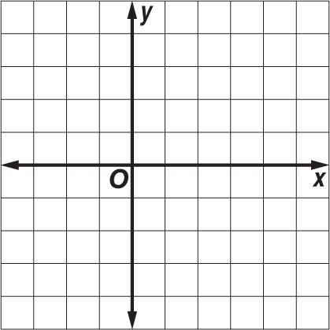
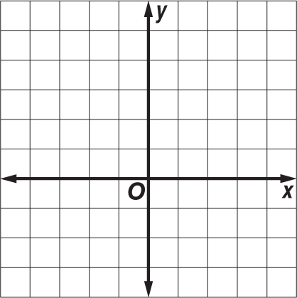

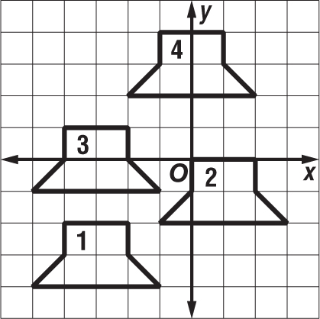
ANIMATION Find the translation that moves
the figure on the coordinate plane.
5. figure 1 → figure 2

6. figure 2 → figure 3

7. figure 3 → figure 4

8. quadrilateral TUVW with vertices T(–3, –8), U(–6, 3), V(0, 3), and W(3, 0); 〈4, 5〉
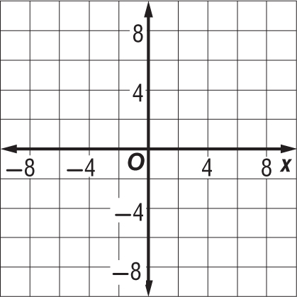

9. △QRS with vertices Q(2, 5), R(7, 1), and S(–1, 2); 〈–1, –2〉
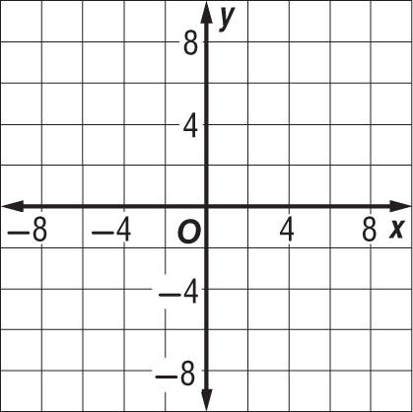

10. parallelogram ABCD with vertices A(1, 6), B(4, 5), C(1, –1), and D(–2, 0); 〈3, –2〉
