9-3 Skills Practice
Rotations

Graph each figure and its image after the specified rotation about the origin.
1. △STU has vertices S(2, –1), T(5, 1) and 2. △DEF has vertices D(–4, 3), E(1, 2), and
U(3, 3); 90° F(–3, –3); 180°
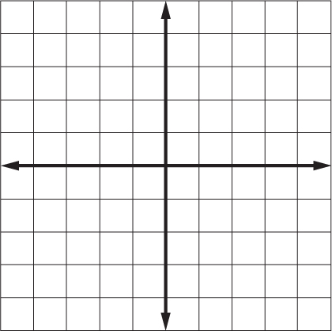
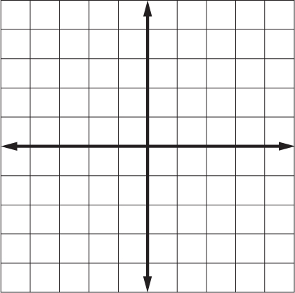

3. quadrilateral WXYZ has vertices 4. trapezoid ABCD has vertices A(5, 0),
W(–1, 5), X(0, 4), Y(–2, 1) and B(3, –4), C(3, –4) and D(0, 0); 270°
Z(–4, 3); 180°
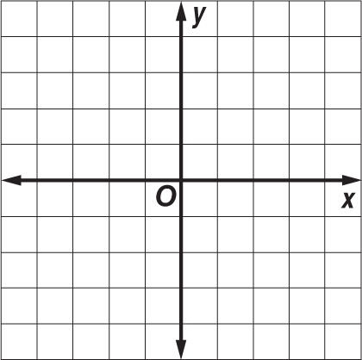

5. trapezoid FGHI has vertices F(4, 4), 6. △LMN has vertices L(–1, –1),
G(4, 2), H(3, 2), and I(-1, 1); 90° M(0, –4), and N(–4, –2); 90°

7. △ABC has vertices A(–3, 5), B(0, 2), 8. parallelogram PQRS has vertices P(4, 7),
and C(–5, 1); 180° Q(6, 6), R(3, –2), and S(1, –1); 270°

