9-5 Skills Practice
Symmetry

State whether the figure appears to have line symmetry. Write yes or no. If so, draw all lines of
symmetry and state their number.
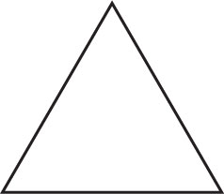
1. 2.

3. 4.
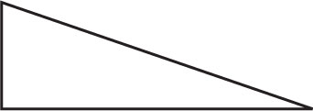

5. 6.
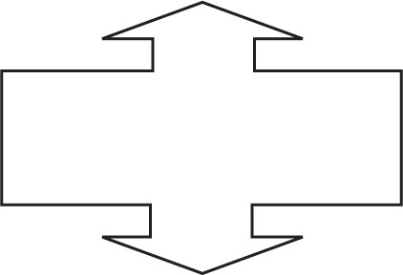

7.
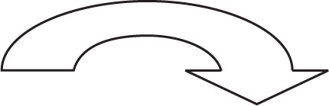

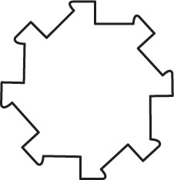
State whether the figure has rotational symmetry. Write yes or no. If so, state the order and magnitude of symmetry.
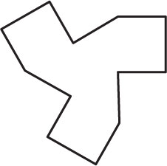
8. 9.

State whether the figure has rotational symmetry. Write yes or no. If so, state the order and magnitude of symmetry.
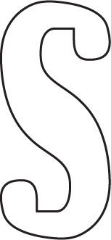
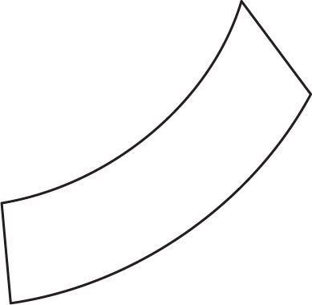
10. 11.

12. 13.
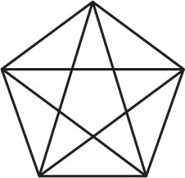

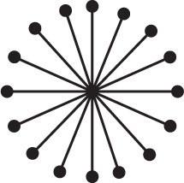
14.

15. STEAMBOATS A paddle wheel on a steamboat is driven by a steam engine that rotates the paddles attached to the wheel to propel the boat through the water. If a paddle wheel consists of 18 evenly spaced paddles, identify the order and magnitude of its rotational symmetry.

