**Name:______________________________**

**Chapter 8 Review**

**1. Find the geometric mean of 17 and 32.**

**2. Solve for *x*.**



**3. The foot of a ladder is placed 6 feet from a wall. If the top of the ladder rests 8 feet up on the wall, how long is the ladder?**

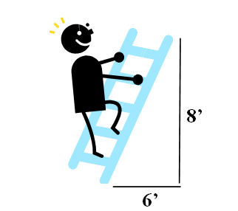

**4. Solve for *y*.**

**5. Solve for $m∠θ$.**

**6. A slide 5 meters long makes a $32°$ angle of elevation with the ground. How high is the top of the slide above the ground?**

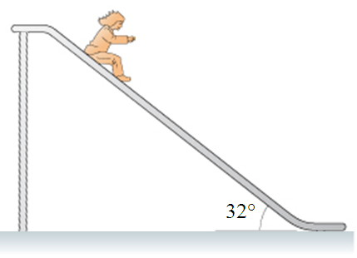

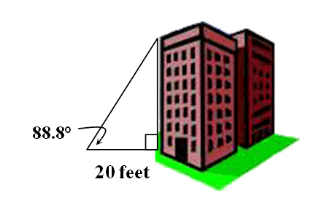**7. Jessica is standing 20 feet away from a skyscraper in New York when she measures the angle of elevation to the top of the building as 88.8°. To the nearest foot, how tall is the building?**

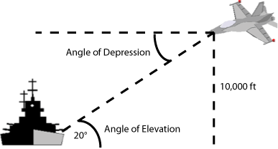**9. A ship’s sonar finds that the angle of depression to a wreck on the bottom of the ocean is 13.2°. If a point on the ocean floor is 75 meters directly below the ship, how many meters is it from that point on the ocean floor to the wreck? Round to the nearest tenth.**



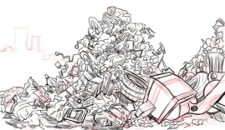

**10.** **You stand 20 feet from the base of a flag pole. You measure the angle of elevation to be $65°$. Estimate the height of the flagpole.**

**11.**

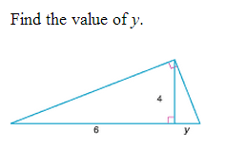

**12.**

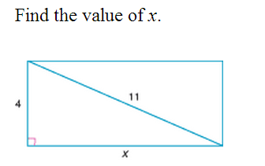

**13.**

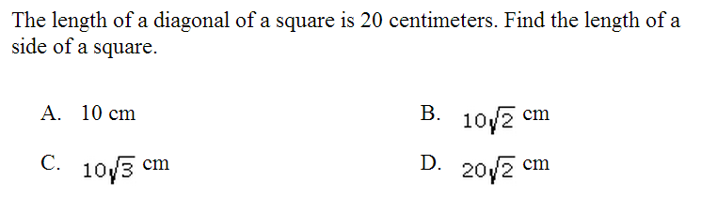

**14.**

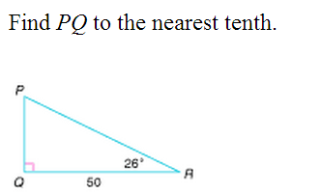

**15. Solve for $m∠θ$.**

