Chapter 9 Test Review
Write the letter for the correct answer in the blank at the right of each question.

1. Given A(3, –7), under which reflection is A′(3, 7)?
A reflection in the x-axis C reflection in the origin
B reflection in the y-axis D reflection in the line y = 5

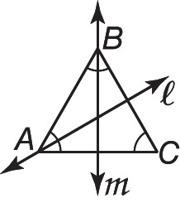
2. Name the image of $\overline{BC}$ under reflection in line m.
F $\overline{BC}$ H $\overline{AC}$
G $\overline{BA}$ J line ℓ

3. How many lines of symmetry does a square have?
A 0 B 2 C 4 D 8

4. What is the image of X(3, 5) along the translation vector 〈–4, 6〉?
F X′(7, –1) H X′(7, 11)
G X′(–1, –1) J X′(–1, 11)

5. Point K(–2, 1) is rotated 90° about the origin. What are the coordinates of K′?
F K′(–2, 1) G K′(2, –1) H K′(–1, 2) J K′(–1, –2)

6. △ABC has vertices A(–2, 1), B(–4, –1), and C’(0, –1) and is reflected in the line y = x.
What is the coordinate of C?
A C′(1, 0) B C′(0, 1) C C’(-1, 0) D C’(0, –1)

7. The point Y with coordinates (–8, 6) is rotated about the origin to Y'(8, –6).
How many degrees was the point rotated?
F 90 G 180 H 270 J 360

8. Find the image of A(3, 7) under a translation along the vector 〈–4, 2〉.
A A′(–7, –5) B A′(–1, 9) C A′(7, 5) D A′(1, –9)

9. Find the magnitude of the rotational symmetry in a regular pentagon.
F 72° G 36° H 30° J 5°

1. ________________

2. ________________

3. ________________

4. ________________

5. ________________

6. ________________

7. ________________

8. ________________

9: ________________

10. Given B(–4, –6), under which reflection is B′(4, –6)?
A reflected in the x-axis C reflected in the line y = –2
B reflected in the y-axis D reflected in the line y = x

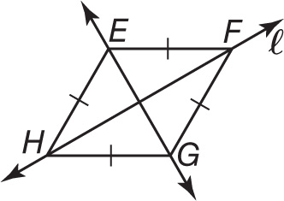
11. Name the image of $\overline{EF}$ under reflection in line ℓ.
F $\overline{GF}$ H $\overline{EH}$
G $\overline{HG}$ J $\overline{FE}$

12. How many lines of symmetry does a regular hexagon have?
A 3 B 4 C 5 D 6

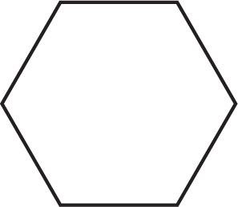
13. Find the magnitude of the rotation of the figure at the right.
F 90 H 60
G 74 J 45

14. What is the image of Y(–4, 7) under the translation 〈3, –5〉?
A Y′(–1, 2) B Y′(–1, 12) C Y′(–7, 2) D Y′(–7, 12)

15. The point I(–4, –1) is rotated 90° about the origin. What is the image of I?
F I′(4, –1) H I′(1, –4)
G I′(4, 1) J I′(–1, –4)

16. The line segment $\overline{CD}$ with endpoints C(5, –7) and D(–3, 9) is rotated 270° about the origin. What is the coordinate of D'?
A D'(–3, –9) B D'(3, –9) C D'(9, –3) D D'(9, 3)

17. Find the image of P(–2, 4) under a translation along the vector 〈6, 5〉.
F P′ (4, 9) G P′ (–4, –9) H P′ (–8, –1) J P′ (8, 1)

18. HIJK is a trapezoid with H(5, 4), I(10, –2), J(–8, –2), and K(–3, 4). Find the coordinates of the image of H under the translation vector 〈10, -11〉.
A H'(20, –13) B H'(15, –7) C H'(–5, 15) D H'(7, –7)

19. Find the reflection of the point A(6, –1) in the x-axis.
F A'(6, –1) G A'(–6, 1) H A'(6, 1) J A'(–1, 6)

10. _______________

11._______________

12._______________

13._______________

14._______________

15._______________

16._______________

17._______________

18._______________

19.________________

