Name:________________________

Geometry T4 Review

1. A certain circular rug has a diameter of 25 ft. Find the circumference of the rug. C = 2πr



1. The diameter of is 124 units, the diameter of is 74 units, and CD = 38 units. Find BC.
2. 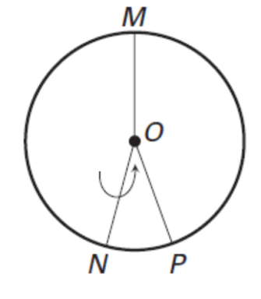Find the measure of $m\hat{MN}$.

161°

28°



1. 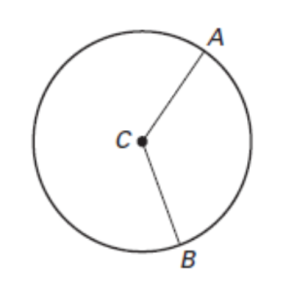Find the length of *Round to the nearest tenth.*

11

134°

1. In the circle below, $\overline{AB}$ ≅ $\overline{CD}$

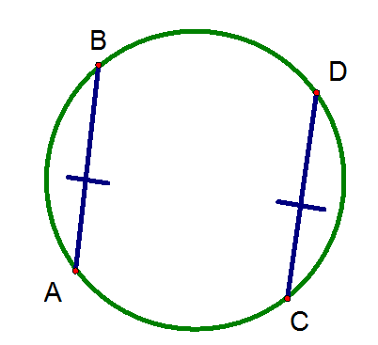and = 58°. Find .

58°



1. In the figures, ≅ and

≅ . Find PQ.

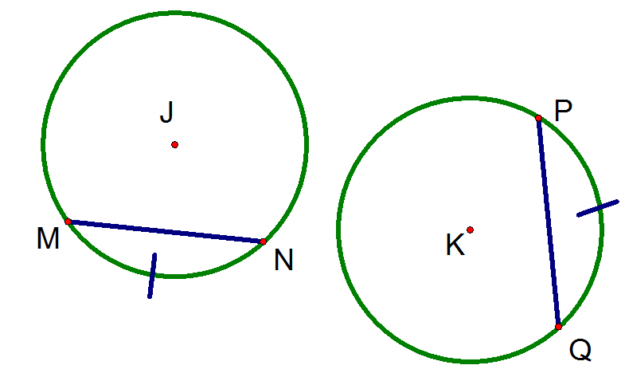

9x - 23

8x - 10



1. In , 89°.

Find .



1. 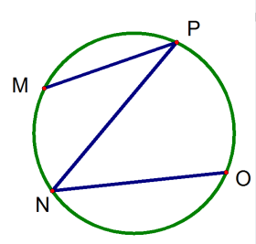Find .

69°

41°

1. 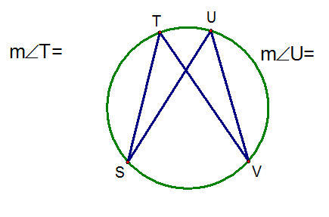Find *m*∠T.

3x - 17

X + 21

1. How many common tangents do the circles have? If no common tangent exists, state *no common tangent*.



1. 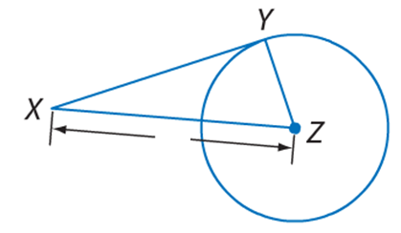Determine whether $\overline{XY}$ is tangent to the circle. Justify your answer.

24

10

26

1. 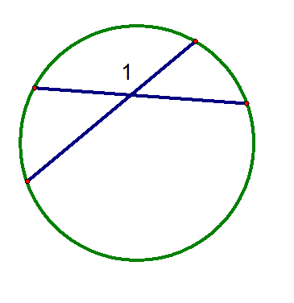Find *m∠*1.

110°

200°

1. 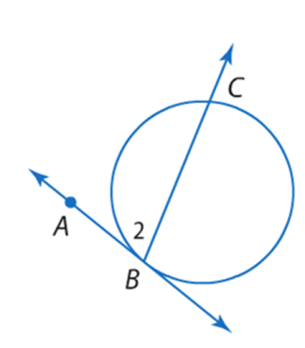Find *m∠*2, where the given line is tangent to the circle.

162°

1. The diagram shows the path of a light ray as it hits a drop of water. The ray is bent, or refracted, at points A, B, and C. If 150° and

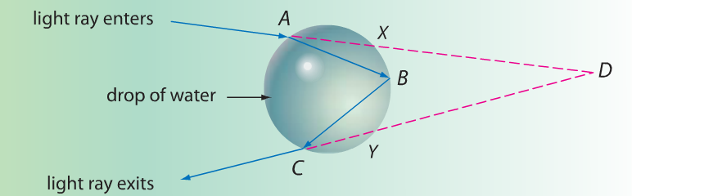 78°, what is m∠D?

1. 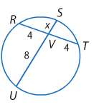Find the value of x.
2. 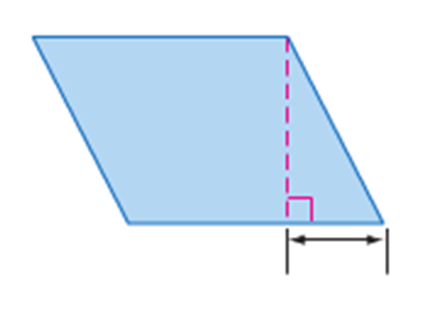Find the perimeter and area of the parallelogram.

30 cm

23 cm

12 cm

1. 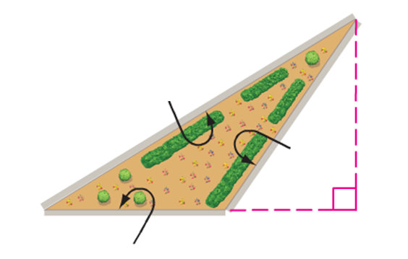Frank needs enough mulch to cover the triangular garden shown. If one bag of mulch covers 12 square feet, how many bags of mulch does he need to buy?

43 ft

18 ft

24 ft

14 ft

1. Find the area of glass used to make the windshield of a van shown.

62 in.

21 in.

97 in.

1. 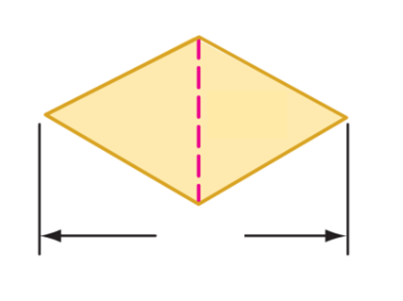Find the area of the rhombus.

26 m

58 m

1. Find x, given the area of the kite.

Area = 323 in2

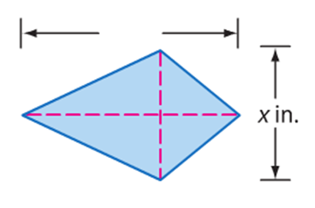

38 in.

1. Find the area of the circle.

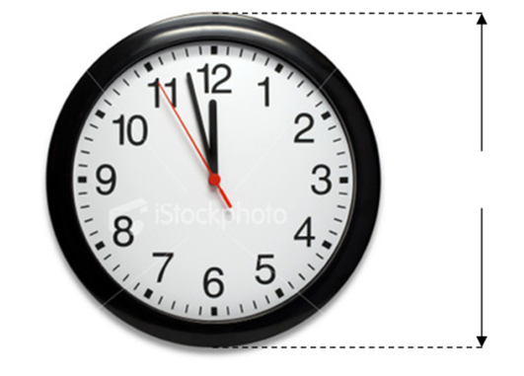

34 cm.

1. Find the radius of a circle with an area of 165 square centimeters.
2. 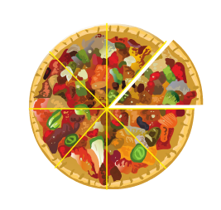A circular pizza has a diameter of 480 mm and is cut into 8 congruent slices. What is the area of one slice to the nearest hundredth?
3. If the two figures are similar, and the area of the figure on the left is 288 yd2, then find the area of the figure on the right.

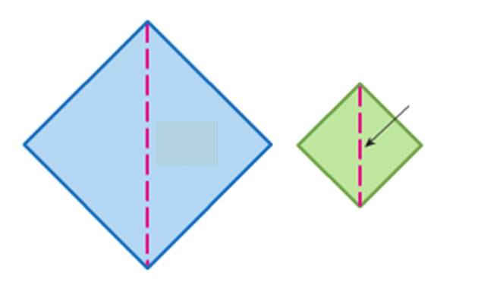

20 yd

24 yd

1. The pair of figures are similar. Use the given areas to find the scale factor from the left figure to the right figure.

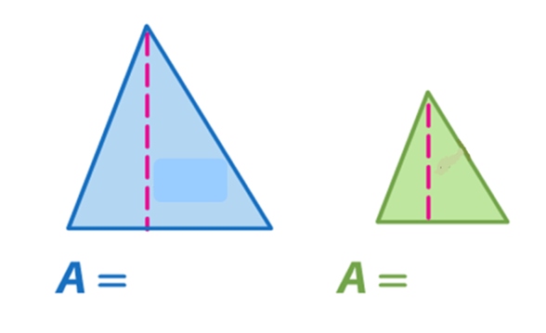

72 cm2

800 cm2

1. 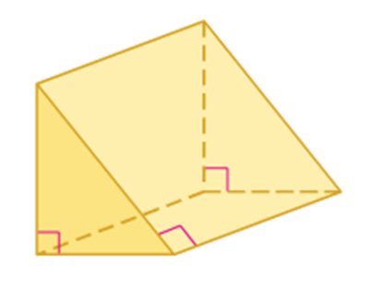Find the lateral area of the prism. Round to the nearest tenth.

56 ft

81 ft

33 ft

1. 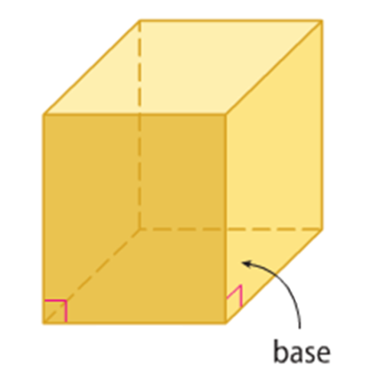Find the surface area of the rectangular prism.

25 ft

16 ft

21 ft

1. 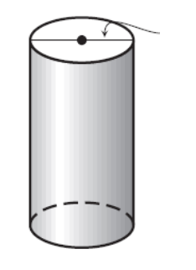Find the surface area of the cylinder with a ***diameter of 13.4in****.*

13.4 in

42 in

1. 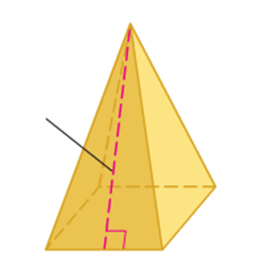Find the lateral area of the square pyramid.

18 m

13 m

1. 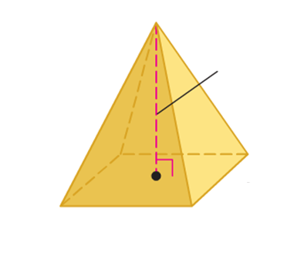Find the surface area of the square pyramid.

23 ft

17 ft

1. 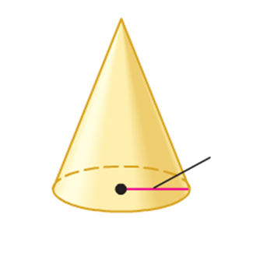Find the surface area of a cone with a radius of 8 meters and a slant height of 18 meters.

18 m

8 m

1. 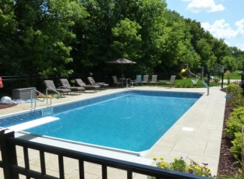A rectangular swimming pool is 20 yards long, 11.2 yards wide, and 1.5 yards deep. Find the volume of the pool.
2. 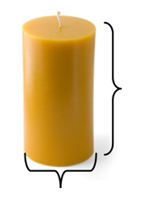Find the volume of cylindrical candle with a height of 20 cm and a diameter of 8 cm.

20 cm

8 cm

1. 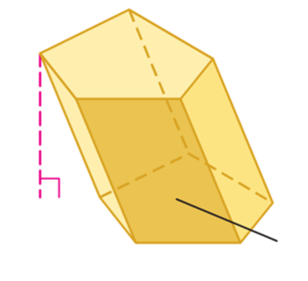Find the volume of an oblique pentagonal prism if the height is 4.7 ft and the base area is 11.9 ft2.

4.7 ft

11.9 ft2

1. Find the volume of the pyramid.

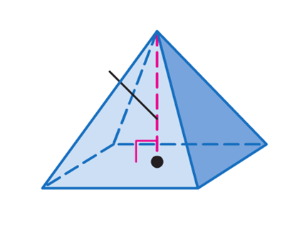

13 cm

10 cm

15 cm

1. Find the volume of the cone.

7 cm

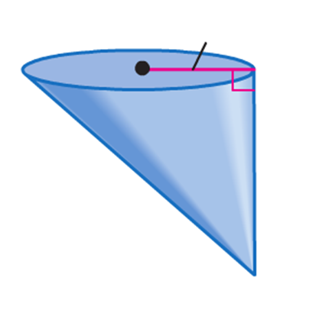

12 cm

1. In Egypt, there exists a pyramid which is 617 feet along one side of its ***square*** base and is 245 feet tall. Find its volume.
2. Find the surface area of the sphere. *Round to the nearest tenth.*

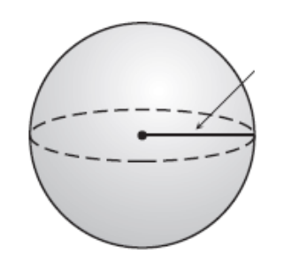

8 in

1. 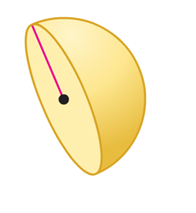Find the volume of the hemisphere. Round to the nearest tenth.

4.3 mm