Term 3 Review Day 2
Write the letter for the correct answer in the blank at the right of each question.

1. Find the geometric mean between 20 and 5.
A 100 B 50 C 12.5 D 10

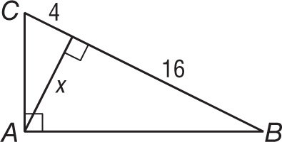
2. Find x in △ABC.
F 8 H $\sqrt{20}$
G 10 J 64

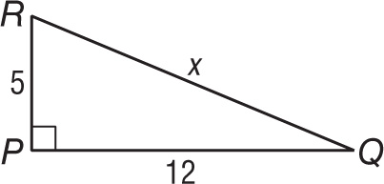
3. Find x in △PQR.
A 13 C 16
B 15 D $\sqrt{60}$

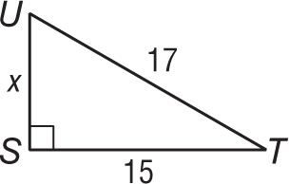
4. Find x in △STU.
F 2 H $\sqrt{32}$
G 8 J $\sqrt{514}$

5. Which set of measures could represent the lengths of the sides of a right triangle?
A 2, 3, 4 C 8, 10, 12
B 7, 11, 14 D 9, 12, 15

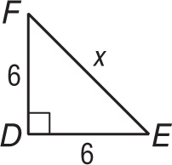
6. Find x in △DEF.
F 6 H $6\sqrt{3}$
G $6\sqrt{2}$ J 12
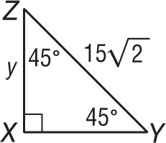
7. Find y in △XYZ.
A $7.5\sqrt{3}$ C 15
B $15\sqrt{3}$ D 30

8. The length of the sides of a square is 10 meters. Find the length of the diagonals of the square.
F 10 m H $10\sqrt{3}$ m
G $10\sqrt{2}$ m J 20 m
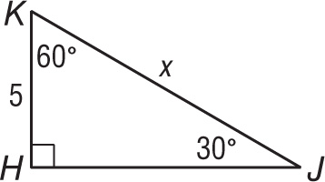
9. Find x in △HJK.
A 5 $\sqrt{2}$ C 10
B 5 $\sqrt{3}$ D 15
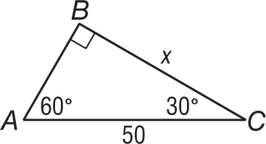
10. Find x in △ABC.
F 25 H $25\sqrt{3}$
G $25\sqrt{2}$ J 100

1._________________

2. _________________

3. _________________

4. _________________

5. _________________

6. _________________

7. _________________

8. _________________

9. _________________

10. ________________

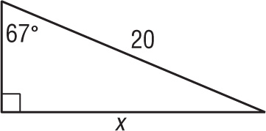
11. Find x to the nearest tenth.
A 7.3 C 18.4
B 17.3 D 47.1

12. Find the measure of the angle of elevation of the Sun when a pole 25 feet tall casts a shadow 42 feet long.
F 30.8° G 36.5° H 53.5° J 59.2°

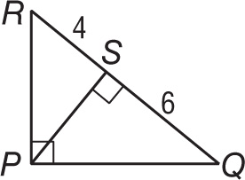
13. In △PQR, RS = 4 and QS = 6. Find PS.
F 2 H $\sqrt{10}$
G 5 J 2 $\sqrt{6}$

14. Which set of measures could represent the lengths of the sides of a right triangle?
A 9, 40, 41 C 7, 8, 15
B 8, 30, 31 D $\sqrt{2}$, $\sqrt{3}$, $\sqrt{6}$

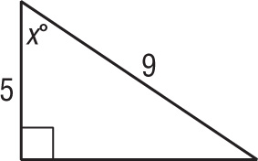
15. Find x to the nearest degree.
F 56 H 34
G 45 J 29

16. If a 20-foot ladder makes a 65° angle with the ground, how many feet up a wall will it reach? Round your answer to the nearest tenth.
A 8.5 ft B 10 ft C 18.1 ft D 42.9 ft

17. A ship’s sonar finds that the angle of depression to a wreck on the bottom of the ocean is 12.5°. If a point on the ocean floor is 60 meters directly below the ship, how many meters is it from that point on the ocean floor to the wreck? Round your answer to the nearest tenth.
F 277.2 m G 270.6 m H 61.5 m J 13.3 m

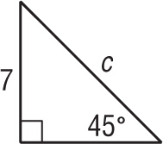
18. Find c.
F 7 H 7 $\sqrt{3}$
G 7 $\sqrt{2}$ J 14

11. ________________

12. ________________

13. ________________

14. ________________

15. ________________

16. ________________

17. ________________

18. ________________

